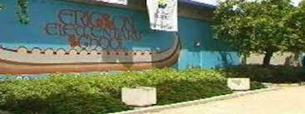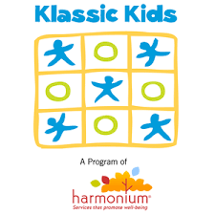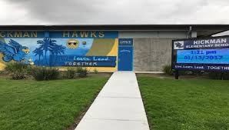

### -18+ years old

### -A minimum of 6 months experience working in day care or recreation program with school age children

### -Youth Leader: 9 ECE units or related field

### -Assistant Site Director: 12 ECE units or related field

### **Related Fields: sociology, psychology, health and nutrition

**Ericson Elementary**

**Gage Elementary**

**Hickman Elementary**

**Loma Portal Elementary**

**Sandburg Elementary**

**Hage Elementary**

**Hardy Elementary,**

**Jerabek Elementary**

**Pacific Beach Elementary**

**Zamorano Elementary**

## Our Sites

## Must Meet the Following Qualifications:

***Klassic Kids Now Hiring!***

We are hiring for the following positions:

Klassic Kids is a licensed childcare that offers care before and after school year round for children entering Kindergarten through 12 years of age.

We provide a safe and nurturing childcare environment that promotes a solid foundation for long-term social and emotional well-being.

# About Us

* ***Assistant Site Director***

$14.69 an hour, Part Time

* ***Youth Leader***

$13.56 an hour, Part Time, Flexible Scheduling

To apply for a position with Klassic Kids please visit [**https://www.harmoniumsd.org/wp/employment-2/**](https://www.harmoniumsd.org/wp/employment-2/)

For any additional information or questions please email Tiffany Johnston at tjohnston@harmoniumsd.org