San Diego State University
5500 Campanile Drive
San Diego, CA 92182

February 1, 2021

Dear Single Subject Applicant,

We understand that you are a student who is applying to be part of the Integrated Teacher Education Program (ITEP). Would you benefit from a scholarship of $12,500 (or $25,000 over two years) to support you during your teacher preparation program?

If so, we invite you to apply to become part of the community of SDSU Noyce Scholars in Mathematics Teaching. The goals of this community are to support highly qualified STEM majors into becoming effective mathematics teachers through their participation in SDSU’s single subject traditional credential or ITEP program and through experiences that continue once teachers begin full-time teaching.

This program provides Noyce Scholars with a scholarship of $12,500 for one year or $25,000 for two years. In other words, as a student in ITEP, you could receive funding in your junior and senior years or receive funding in just your senior year. It includes opportunities for Scholars to improve their mathematics teaching practice during and after their degree program. In exchange for receiving the money, you will be required to teach 2 years of secondary mathematics in a public school in a high-need district in California (for example, San Diego Unified, Grossmont Union, or Sweetwater Union) for each of the years you receive funding; this needs to be completed within seven years of your graduation. If this condition is met, the scholarship/loan is “forgiven” and no repayment is required.

On the next few pages you will find instructions and materials needed for applying for the Scholarship. Please be sure to review the entire application and, in particular, the eligibility requirements, in particular, Section C: Eligibility Requirements. If you have questions, contact Sr. Nickerson. Email your completed application to Dr. Susan Nickerson, at snickerson@sdsu.edu. Use the Subject Line: Noyce Scholarship Submission

We encourage you to apply no later than August 8, 2021. We would like to review applications and have interviews in August but if you need more time, please let Dr. Nickerson know.

For additional information, please contact Dr. Susan Nickerson (snickerson@sdsu.edu), Dr. Janet Bowers (jbowers@sdsu.edu) or Dr. Randy Philipp (rphilipp@sdsu.edu). We look forward to working with a thoughtful group of prospective teachers.

Sincerely,
 | 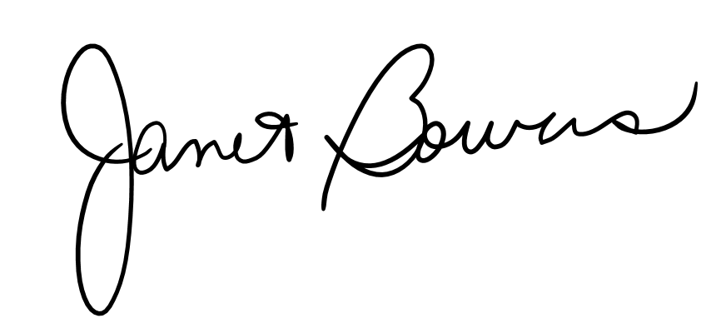
Dr. Nickerson | Dr. Bowers | Dr. Philipp

SDSU Noyce Scholars in Mathematics Teaching: UPTEMPO
Soft Deadline for applications August 8, 2021

Application Checklist

To apply for this program, submit items below:

1. Applicant Information Sheet
2. Confirmation of Eligibility Sheet
3. Essay Response
4. Reference contact for Letter of recommendation

As the SDSU campus is not currently delivering mail, please email the completed application packet to snickerson@sdsu.edu, as indicated on the first page above.

If you are not able to print and sign and scan (or take a picture) of the signed application, leave the signature field blank (page 4), send in the application by email as instructed, and in the body of the email or in a separate email to snickerson@sdsu.edu, say you understand the items in the table (page 4).

Directions for the letter of recommendation
Identify someone to supply a letter of recommendation. On the Applicant Information section of your application, there is a space for you to provide the name and e-mail address of the reference. Please request that the letter of recommendation go directly to Dr. Nickerson on your behalf. It is your responsibility to follow up to be sure that the letter is submitted in a timely manner.
Relationship of Recommender to You. Recommendation from family and friends will not be considered. A recommender must state how they know you in their letter. Recommended references include a professor, an employer, and/or classroom teacher where you have volunteered or worked.

Criteria to Be Considered. Ask that the letter directly comment on some of the following:
- Your qualifications for a teaching career or potential for success as a teacher
- Your experience in multicultural settings
- Your educational experiences
- Your employment experience or your experiences as a volunteer
- Your experience teaching or supervising students or other groups of individuals
We will conduct interviews with the most highly qualified applicants. THANK YOU.

Applicant Information Sheet

Name (Last) (First) (MI) ___________________________________________________

SDSU Red ID Number ___________________________________________________

Best Contact Phone Number ________________________________________________

Email Address _______________________________________________________
Undergraduate Major _____________________________________________________

Expected Month/Year of graduation _________________________________________

Reference and contact _____________________________________________________
How did you find out about the Noyce Scholar Program? Please check all that apply.

_____ email
_____ professor
_____ announced in my class
_____ friend
_____ flyer or poster
_____ other: ___________________________________________________________

Confirmation of Eligibility
Noyce Scholars must:
- be ‘enrolled’ in the ITEP program majoring in a STEM discipline;
- plan to complete SDSU’s teacher credentialing program;
- commit to teaching mathematics for at least two years in a public school in a high needs school district for each year of funding;
- commit to responding to surveys and other requests for information, and participate in learning opportunities during the credential program; and
- be a United States citizen, national, or permanent resident alien.

Requirement | Your Response
I graduated or will graduate with a major in a STEM discipline. | Major _______________________________  Year of Graduation ___________
I applied to SDSU’s single-subject or single-subject bilingual mathematics teacher credential program or ITEP and, if accepted, I plan to attend. | ___ YES I applied to, and if accepted, plan to attend SDSU’s teacher credential or ITEP program  ___ OTHER. Explain ___________________
I understand that if I am accepted as a Noyce Scholar, I will receive a $12,500 scholarship loan for one or for each of two years. The money does not need to be repaid if I teach for at least two years in a school in a local high-need district for every year of funding.* | ___ YES I understand that if I receive one year of funding, I do not need to repay it if I teach 2 years in a high needs district. If I receive two years of funding, I do not need to repay it if I teach 4 years in a high-need district.  ___ OTHER. Explain ___________________
I understand that I will need to respond to surveys and requests for information and participate in learning opportunities during and after the credential program. | ___ YES I understand.  ___ OTHER. Explain ___________________
I am a U.S. citizen, national, or permanent resident alien. | ___ United States citizen  ___ National  ___ Permanent resident alien

My signature below indicates that the information provided in the table is accurate.
Name (Please print) ______________________________________________________
Signature† __________________________________ Date ___________________
* The District should be identified as a high-need district in that at least one of its schools has a high percentage of individuals from families with incomes below the poverty line.
†If you are not able to print and sign and scan (or take a picture) of the signed application, see instructions on page 2.

Essay Response

The commitment associated with this Noyce scholarship is that you will teach mathematics two to four years in a public high–need school district to be completed within eight years of attaining your credential. In no more than 500 words, describe (a) your interest and enthusiasm for mathematics teaching, and (b) your ability and commitment to working in a school in a high–need district.

