Project BEAMS: Behavioral, Emotional and Mental Health Supports in Schools: Collaborative Practices to Improve Special Educator & School Psychologist Training
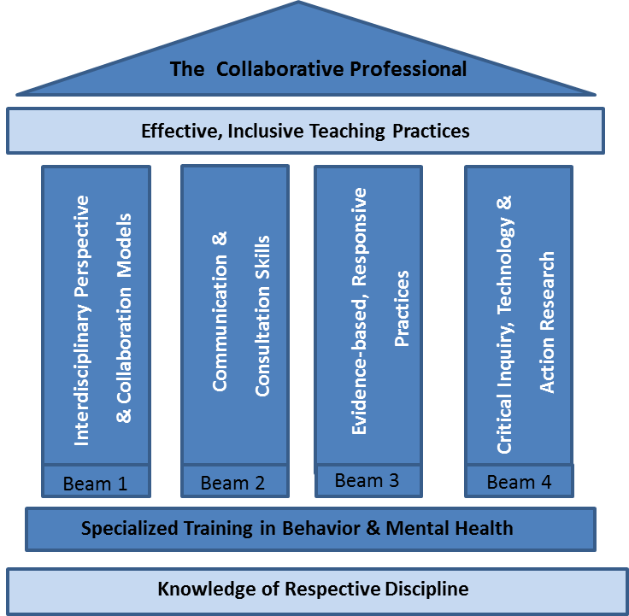
Project BEAMS will improve preservice preparation of school psychologists (SP) and special educators (SE) to serve diverse students with behavioral, emotional, and mental health challenges in California's public schools.
Shortages exist of highly trained, multicultural teaching and support personnel to serve students with high-intensity behavioral and mental health needs in schools. This group frequently presents with a broad range of disorders and disabilities that impact academic, cognitive, and social functioning. Focused instruction, in addition to, intensive individualized interventions is often required to appropriately address these multifaceted needs. This calls for professional practice in classrooms to be well coordinated, integrating expertise across multiple disciplines in order to improve the quality of services provided.
Project BEAMS involves SPs & SEs in interdisciplinary training and shared collaboration via:
- Research-based courses in Autism, Ethics, & Applied Behavioral Analysis;
- Seminars, where trainees discuss readings, give cross-disciplinary presentations, and practice collaboration;
- Clinical practicum experience, with paired SPs & SEs working together in classrooms to provide intensive interventions;
- Summer institutes, where SEs & SPs will learn about leading research (Day 1) and build capacity around mental health services (Day 2);
- Co-attendance at professional conferences.
Competencies include interdisciplinary knowledge & collaboration; enhanced communication & consultation; evidence-based interventions with cultural contexts for understanding behavior and mental health; and action research & data-based decision making.
This 5-year training project will support 14 cross-cohort SP & SE trainees annually (7 SP & 7 SE) for two, 2-year training cycles as they pursue their multi-year graduate-credential programs. Monthly stipends, BCBA supervision allowances, and conference monies are provided to support this specialty training ($11,500-$12,500 per year).

Contact: Dr. Bonnie Kraemer @ bkraemer@mail.sdsu.edu for grant application and information

