“Draw a Picture of Something You Learned:”
A Critical Multimodal Analysis of Multilingual Students’ Classroom Drawings

Abstract: Drawn from a larger study on implementing visual-based literacy strategies across the curriculum, this article focuses on the ways multilingual students leveraged multimodal resources to express their perceptions and reflections on their innovative classroom learning experiences. Informed by a critical multiliteracies perspective, we analyzed a data set of 22 drawings, created as exit tickets, to find out how students illustrate their response to the curriculum. Our 4th to 6th grade students, identified as English Language Learners through district evaluations, leveraged multimodal techniques to reflect on their content learning and insert themselves in to the classroom learning process as successful and accomplished community members, sometimes challenging the deficit labels assigned to them with their status as English Learners.

Keywords: arts, drawing, elementary, multilingual, multiliteracies

Marva Cappello and Reka C. Barton
&
Marva Cappello is a Professor of Literacy Education at San Diego State University where her focus is on literacy and qualitative research methods. Dr. Cappello is the Director and Founder of the Center for Literacies (CVL) which spotlights visual-based methods as equitable practice for pedagogy and qualitative research. Recent publications of her visual-based research have been published in the English Teaching: Practice & Critique, Ubiquity, and The Reading Teacher.

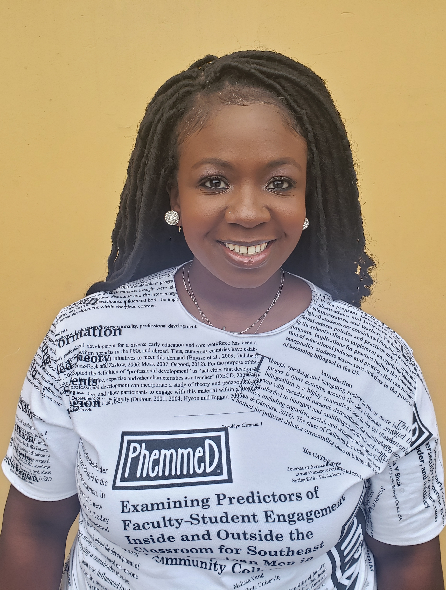
Reka C. Barton is a Postdoctoral Fellow in the School of Leadership and Education Sciences at the University of San Diego and a visual researcher at the Center for Visual Literacies at SDSU who examines the educational experiences of Black and Brown girls at the crux of language, race, and literacy. She has recently published in Children’s Literature in Education and the Journal of Early Childhood Literacy.

.

I
n our work as former classroom teachers, educational researchers, and teacher educators near the United States and Mexico border, we often find our conversations centering on the ways we can enhance instruction for students at all levels who are new to English or have learned English as an additional language in academic settings. As educators who have served in classrooms before, during, and after the language education legislation in mandates of California, we also recognize the stigma and politics attached to the English Language Learner label. California defines an English Learner as “a child who does not speak English or whose native language is not English,” (Education Commission of the States, 2014). This limited legal definition does not provide for the assets the simultaneous bilinguals or the developing multilinguals bring into our classrooms daily. We believe that there is a more expansive linguistic repertoire that the students designated with this label possess, and there is better and more specific terminology to describe our students. However, in this article you will see references to the term English Language Learners (ELLs) or English Learners (ELs) as designated by the district and school site and not used because we advocate for these labels.

Our discussions are not only grounded in research on language learning and cultural contexts, but we specifically approach the topic from a critical multiliteracies perspective. Like others who work from multiliteracies perspectives, we capitalize on expanding definitions of literacy to include visual and multimodal texts for the communication of academic knowledge. We consider this an important component of our students’ communicative repertoires. Indeed, we are interested in “critical questions regarding the place of learners' plurilingual resources within their multimodal repertoires, and how students' repertoires might figure in language pedagogies” (Early et al., 2015, p. 449). More expansive definitions of literacy are critically important in schools because they provide more accommodating and flexible pathways to access and express curricular understandings (Ranker, 2014). This is essential when working with students who are learning English. Indeed, multimodal texts can be used for students to demonstrate knowledge where language does not impede comprehension (Cappello & Lafferty, 2015; Eisner, 2002). We also believe visual texts can serve well as linguistic resources to support English language development as non-linguistic representations “have a positive effect on student achievement and provide diversity in the way that students process new information” (Marzano et al., 2001, p. 86). There has been a recent and consistent call to “highlight the possibilities, challenges, and understanding that a multimodal lens brings to language education” (Early et al. 2015, p. 251).

Equally or perhaps even more importantly, multimodal pedagogies and research methodologies have demonstrated how approaching literacy research from an expansive perspective provides insight on the complexity of students’ literacy practices. Thus, these methods have the potential to dismantle deficit views of our learners, which are too frequently assigned to racial and ethnic minorities (Muhammad & Womack, 2015) and those with developing English language skills (Hayik, 2011; Zapata & Van Horn, 2017).

Building upon the documented importance of multiliteracies in classrooms and with the specific benefits for our multilingual students in mind, the research questions that guided our study are: 1) In what ways do visual-based opportunities in the classroom add to multilingual learners’ linguistic repertoires?; and 2) How do school-sanctioned drawings provide space and opportunity for elementary multilingual learners to reflect on curriculum content and social identities in the classroom?

A Critical Multiliteracies Framework

To ensure a critical perspective, a critical multimodal literacy framework (Cappello et al., 2019) guided our understanding of the student drawings. This framework played an important role in organizing our thinking, because in addition to focusing on the use of multimodal tools for communicating and learning, it provided a critical perspective on the relationships and roles in the classroom, offering space for critiques and re-presentations. Further, a critical multimodal literacy framework affords a scaffold to better understand inclusive literacy practices that promote equity and social justice. Critical multimodal literacy was useful to help us describe the ways multimodal tools are used as linguistic resources for personal meaning-making, critique, and social agency and includes the following four dimensions: communicating and learning with multimodal tools; restorying, representing, and redesigning; acknowledging and shifting power relationships; and, leveraging multimodal resources to critique and transform sociopolitical realities (Cappello et al., 2019).
“When viewed through a critical perspective, offering students a range of modes for expression provides additional opportunities to self-reflect and to situate themselves within complex concepts, sometimes challenging identity narratives assigned to them.”

Other researchers have used visual methodologies to understand students’ conceptualizations of complex topics as well (Ajayi, 2015; Brown & Albers, 2014; Ghiso & Low, 2013; Hayik 2011). For example, Brown and Albers (2014) used drawing exercises to understand how fifth grade students conceptualize and visualize gender, specifically, “addressing content concepts such as compromise, criminal and civil law and the constitution” (p. 87). Hayik (2011) explored the ideological and religious conflicts among her Israeli-Arab minority students in Galilee. She found that her critical literacy curriculum created space for students to create sketches that “offered interesting insights into students’ understandings of texts and themselves” (p. 95). In Ajayi’s (2015) work, three Nigerian female high school students “used critical multimodal literacy to critique texts and reconstruct unequal social structures” (p. 217) “that have historically marginalized them from full participation in society” (p. 220), leading to a call for change in the English curriculum. Comic drawings offered students a way to “dig beneath dominant narratives” to get at the complexity of students’ immigration experiences and share alternative and additional accounts of their personal experiences (Ghiso & Low, 2013, p.33).

These studies demonstrate how when viewed through a critical perspective, offering students a range of modes for expression provides additional opportunities for students to self-reflect and to situate themselves within complex concepts, sometimes challenging identity narratives assigned to them. We believe a multiliteracies approach can empower students to learn English in similar ways, especially necessary when working with students who are labeled in school as an English Learner, too often seen as a badge of disadvantage. Further, these examples recognize that literacy is not neutral, without bias and when given the opportunity “students draw on their own knowledge and identities as resources to shape literacy learning” (Ajayi, 2015, p. 217).

Our study demonstrates that the ways school-sanctioned drawings provided powerful opportunities for elementary-aged multilingual learners to reflect on content understanding and challenge dominant identity narratives assigned to them as English Learners in their classrooms. Specifically, we wondered if school-sanctioned drawings would provide space and opportunity for elementary multilingual learners to express more than the curriculum and articulate their roles in the classroom learning, and thus asserting their identities.

A Critical Perspective on Classroom Drawing

We chose drawings for this exploration of students’ perspectives for several reasons. The drawings at the core of our study were created in response to a multimodal curriculum, so it makes sense to offer visual pedagogies for reflection. However, most importantly, drawings in school can serve as an equitable educational practice through personal connection with content and by providing multiple pathways for communication.

Like other advocates for drawing in literacy and content area curricula, we believe it is an inclusive practice because we know students need “many ways of thinking and responding available to them” (Short et al., 2000, p. 160). We agree with Whitin (2005) who states that equitable classroom practices must include a wide range of tools for expressing understanding. Multiliteracies classrooms provide students with varying modes to navigate and respond to the curriculum. Visual methods are sometimes simply more efficient demonstrations of knowledge than traditional linguistic approaches used in school (e.g., family trees and cell diagrams) and they can also serve as mediational means that scaffold understanding (e.g., picture book illustrations and timelines). Further, drawing can support idea development and refinement, easily revised and reshaped with growing understanding. In her work with young children, Brooks (2009) showed how students’ drawings can “bring something more clearly into consciousness. . . be a visual representation of a thought and/or idea” (p. 339). Relatedly, Whitelaw and Wolf (2001) found drawing may foster movement from concrete to abstract thinking.

Arts-based curricula and specifically drawing in the classroom has the potential “for students to experience deep structures of meaning where they emotionally connect with the content and sustain learning” (Zoss et al., 2010, p. 136). In her work studying students’ linguistic repertoires, D’warte (2019) had student participants create “language maps, a pedagogical task that engaged students in creating visual representations of their individual practices and experiences” (p. 666). These language maps were created in class and revised at home with feedback from family. This process and the ensuing discussions validated home languages, helped English Learners form a stronger relationship between language and identity, and provided a place for teachers to expand literacy practices. Indeed, students’ maps provided teachers with additional insights into their language processes as well as the ways they bridge the linguistic worlds of home and school. In Harman and Shin’s (2018) study, students with multiple marginalized identities (emergent bilingual, lowest reading group, and labeled disruptive) worked together to create multimodal compositions. As participating students emotionally connected with the project and each other, they challenged their assigned/adopted classroom identities and “seemed much less marginalized by their peers” (p. 233). Drawing and other visual-based teaching and research methods “enable us to investigate the potential of drawing as an alternative way for children to create and represent themselves in relation to literacy” (Kendrick & McKay, 2005, p. 112). Personal and emotional connections impact student engagement as well (Marquez-Zenkov & Harmon, 2007; Whitin, 2005). Whitin (2005) found “children who invested very little in other academic tasks became very engaged in sketching . . . particularly when they were able to relate their personal interests to their visual compositions” (p. 394). Therefore, drawings were intentionally chosen as an instructional and research method as they offer a tool for representation where “our language abilities do not define the limits of cognition” (Eisner, 2002, p. 12).

Visual Texts and Language Learners

Providing students opportunities to use visual texts, including drawing, within and across the curriculum, provides specific benefits for language learners in our classrooms (Early et al., 2015). Our multilingual learners face all the typical challenges of school in addition to learning complex academic concepts with disparities in cultural and linguistic knowledge. Thus, we need to pay special attention to the scaffolds and pathways we provide for academic success. In their introduction to their special TESOL issue, Early et al. (2015) established their purpose to “highlight the possibilities, challenges and understandings that a multimodal lens brings to language education” (p. 451). However, they warned us that visual-based pedagogies “entail much more than the simple addition of visual literacy to the crowded list of skill sets demanded of English language learners” (p. 447). Teachers and researchers have found integrating visual literacies assists language learning through accountable talk (Cappello & Walker, 2016) as well as academic vocabulary development and metacognition (Cappello & Lafferty, 2015). One specific aspect of visual literacy, i.e., transmediation—the process of shifting among communicative modes—also has been found to increase English Language Learners’ access to academic discourses (Wolfe, 2010).
“Our multilingual learners face all the typical challenges of school in addition to learning complex academic concepts with disparities in cultural and linguistic knowledge. Thus, we need to pay special attention to the scaffolds and pathways we provide for academic success.”

Many of the English Learners in our classrooms have developed rich skills for viewing and visually representing ideas as a way to negotiate their still developing linguistic skills. Including drawing within the sanctioned curriculum provides opportunities to shine the light on these students, which results in social classroom benefits as well. Another body of research focuses on the ways multiliteracies can support identity development for our English learners. The middle school English Learners in Danzak’s (2011) study created graphic retellings of their immigration stories in a project designed to help students learn more about the English language, as well as their classroom identities. In their case study of a 14-year-old English learner, Vorobel et al. (2020) described the transformation in her classroom status as she expressed herself and her identity through multiliteracy practices designed for self-reflection that included “identifying and missing her homeland and family”, as well as her “resistance to negative representation of ELs in the high school” (p. 332).

These studies show how “visual literacy expands students’ opportunities to build productively on print-based literacy, even the playing field to some extent for English Language Learners, and connect youth in creative ways to think about being citizens in their communities and the world” (Holloway, 2012, p. 150). However, much of the research on using visual texts as classroom pedagogy for literacy learning and identity work is focused on adolescents (Danzak, 2011; Marquez-Zenkov & Harmon 2005; Vorobel et al., 2020; Wolfe, 2010) or language teachers (Holloway, 2012; Zoss et al., 2010). This research will add to the literature as we explore the ways elementary multilingual learners use multiliteracies to express content understanding as well as their classroom identities as English Learners.

Visuals as Agentive Texts

Key to our choice of exploring drawings as data is the potential for visuals as agentive texts. We agree with Hayik (2011) who notes that offering students drawing as a way to communicate understandings may provide an instructional opportunity where students have “greater agency than they traditionally experienced in their language classroom to choose how to represent and what to include in their images” (p. 99). Kedra and Zakeviciute (2019) provide an anecdote in their editorial for a special issue of Journal of Visual Literacy that demonstrates how drawings served as an agent of understanding in a multilingual context:

A bilingual five-year-old girl is trying to explain to her mother what she was doing at gymnastics class. Despite her best efforts to overcome the excitement, speaking a mixture of two languages and not yet perfect pronunciation, the mother is left totally puzzled. However, the child does not give up. She takes a piece of paper with a colour pencil and starts drawing gymnastics’ activities one-by-one, adding some oral explanation to indicate action, the movement of people and objects in the drawing (p. 1).

Although the authoring experiences occurred in a community technology center and not in a school setting, Hull and Katz (2006) found that multimodal composing “helped to position participants to articulate pivotal moments in their lives and to assume agentive stances toward their present identities, circumstances, and futures” (p. 44). The authors attribute this to providing the right (multimodal) composing tools.

The teenage student in Vorobel et al.’s (2020) case study created visuals for an assignment designed for self-reflection and expression of identity where she expressed “resistance to negative representation of ELs in the high school” (p. 332). Others used visuals as agentive texts to create counternarratives (Cappello et al., 2019; Kuby 2012) that impact their standing in the classroom (Harman & Shin, 2018). Students as young as five and six years old created agentive images that illustrated their understanding of critical topics of racial segregation in Kuby’s (2012) study that included visual responses to picture books. Kuby’s analysis revealed the multiple ways students leveraged visual authorial moves to resist dominant (white-centered) discourses about the civil rights movement. The aforementioned focal students in Harman and Shin’s (2018) study leveraged their multimodal resources and composition skills to shift their positions within the classroom and the larger community to become agentive text makers. In this study, the semiotic affordances of the curriculum design created opportunities for academic as well as social growth.

These studies demonstrate how visual-based methods and specifically drawing in school has great possibility as an equity pedagogy, provides specific benefits for our multilingual learners, and has potential to be understood as agentive texts. In this article, we add to the body of research exploring both the what, the curricular content and social identities, as well as the how, the processes of classroom learning that add to elementary multilingual students’ linguistic repertoires.
Our Research Context

In Southern California, the location of our study, both bilingualism and multilingualism are realities for many of the students in the TK-12 and university schooling systems. According to the California Department of Education, our public-school systems are comprised of 18.6% English Language Learners, which translates to 1.15 million students learning English at a range of levels. That statistic represents those students that have an assigned designation of English Language Learner based on standardized evaluations. However, if we include the “Ever-ELs” as designated by the state, the total number of students that make up the bilingual and multilingual population of California public schools is 2,282,001, over 37% of the total students enrolled in public schools across the state (California Department of Education, 2019).

We studied at a large urban elementary school located 10 miles from the Mexican border. This site was chosen because the principal and many teachers were Cappello’s former students and were thus familiar with visual-based instruction and multiliteracies frameworks. The school was also chosen because of its demographics. Of the approximately 1100 students in grades kindergarten through sixth, over 90% are Latinx of which 56% are designated as English Learners. We focused on upper elementary classrooms; 73 students in grades four, five, and six, as well as their three teachers participated. For the purpose of this exploration, we focused on the 35 of the 73 students in these grades who were identified by school measures as English Learners or recently redesignated English Learners. Ten fourth graders, eight fifth graders, and 17 sixth graders met these criteria.

This research is drawn from a larger descriptive multiple case study (Cappello & Walker, 2016) of visual based classroom curricular innovations which included several qualitative methods for inquiry, including observations, interviews, and document analysis. The broader work was organized around three multi-tiered coaching cycles that included collaboration, modeling, observation, and reflection, and extended over six months. The three curricular innovations introduced into the literacy and content area curriculum included Visual Thinking Strategies (Cappello & Walker, 2016; Yenawine, 2013), Prove It (Cappello & Walker, 2019), and Talking Drawings (Cappello & Walker, 2021; McConnell, 1992). These strategies were chosen in collaboration with the teachers because they aligned well with the already planned curricular maps and included strategies for viewing and analyzing images, as well as visually representing and demonstrating knowledge. The research shared here is excerpted from that broader work with the aim of focusing on multilingual students’ perceptions and reflections.

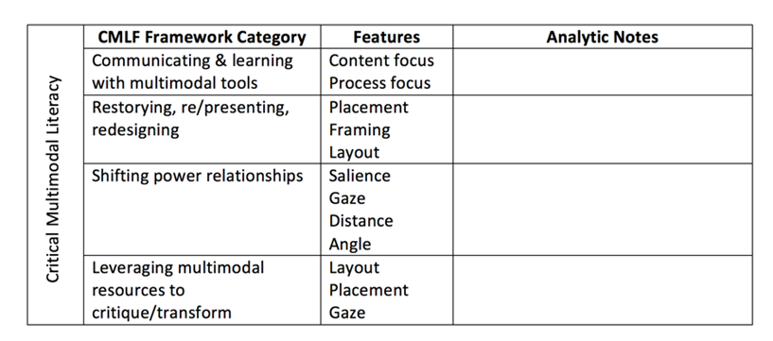
All participating students created exit tickets as final reflections after the three cycles of varied visual based instruction across the curriculum were completed. Students were provided with the prompt to “draw a picture of something you learned.” This lead was intentionally vague and carefully constructed in order to support a wide range of responses. Students completed the exit tickets at their desks using only a pencil just like any other sanctioned schoolwork. As a reminder, drawings were intentionally chosen as classroom methods for communicating student reflections on the visual curriculum because they are also visual in nature and because they offer a tool for representation where “our language abilities do not define the limits of cognition” (Eisner, 2002, p. 12). Our data set included 22 multimodal exit tickets; all of the compositions created by the English Learners in grades four through six who returned their consent and assent forms.
Figure 1
Analytic Template

Multimodal Content Analysis

Student drawings were viewed through the lens of a critical multimodal literacy framework (Cappello et al., 2019) to determine how images conveyed curricular understanding and how they reinforced or contradicted dominant classroom ideologies of English Learners. We explicitly used the critical multimodal literacy framework to guide our thinking around these data, because although semiotic interpretations of the images are helpful, we wanted to be sure that our analysis was critical in nature. We were also influenced by Serafini & Reid’s (2019) procedures for multimodal content analysis (MMCA). MMCA provided a “multifaceted and flexible methodology” to “analyze the semiotic structures and resources used in various multimodal texts” (p. 3). Moreover, we were able to engage in an iterative analytic process in which we continually returned to the theory to clarify and confirm our procedures. Serafini and Reid (2019) outline eleven steps in the MMCA procedure as follows:

(1) Recognizing an Area of Interest; (2) Developing Initial Research Questions; (3) Constructing the Data Corpus; (4) Defining the Object of Study; (5) Developing Initial Categories; (6) Developing the Analytical Template; (7) Testing the Analytical Template; (8) Applying the Analytical Template to the Data Corpus; (9) Constructing Potential Themes; (10) Implications of the Analysis; and (11) Dissemination of Findings (p. 9)

Our consistent and reflective conversations regarding the English Learners we work with helped us recognize an area of interest and develop initial research questions. The data corpus was constructed by the broader research context conducted by Cappello but together we decided to focus on the exit tickets as our object of study because they were not tied to a specific instructional innovation or content area. Further, these drawings were the most open-ended and prompted reflection.

We kept the four dimensions of the critical multimodal framework (Cappello et al., 2019) in mind as we began our analysis: communicating and learning with multimodal tools; restorying, representing, and redesigning; acknowledging and shifting power relationships; and leveraging multimodal resources to critique and transform sociopolitical realities. However, when we met to test this framework against the data, we found these dimensions too broad for our specific investigation. Therefore, we followed Serafini and Reid’s (2019) suggestion and collaborated to create a more specific analytic template to apply to the data to guide our analysis (see Figure 1). This template was organized around the four dimensions of the framework, but also highlighted the specific visual features students might employ to communicate their ideas and understandings. These visual techniques are grounded in social semiotic interpretations (Kress & van Leeuwen, 2006) and we used Callow’s (2013) explanations to help us understand the visual moves used by our students and what those elements might help them communicate. We focused on the metafunctions of interacting and relating that show “feelings, attitudes, credibility, and power relationships” (Callow, 2013, p. 49) as well as design and layout that organize for “logical and cohesive texts” (p. 75). This helped us focus on how (named in the features) our participants communicated in/through each of the four dimensions. This template provided us a tool for organizing our thinking and created an analytic path toward constructing themes in the data.

The Collective Multimodal Compositions

The findings in this section highlight our analysis of the collective set of 22 multimodal compositions with specific attention to ways visual authorial moves might be integrated into our students’ communicative repertoires. Our multilingual participants created varied compositions as their exit tickets. Although not directed to do so by the prompt “draw a picture of something you learned”, nearly all of the 22 images included written text in some form. Some of our multilingual students used callouts to label lesson materials and members of the community depicted in their drawings (“detective book,” and with arrows indicating a penguin’s “beak” and “yellow feathers''). We found this use of callouts and arrows to be reminiscent of content area textbook illustrations. Other multilingual learners created captions confirming or extending the visual-text features, such as “every detail counts and has a purpose” and “the day we did the visual thinking strategy.” Several students included speech or thought bubbles that provided the viewer with otherwise hidden information, including “I’m done” and assigning Cappello the narration, “Now draw something different in your 2nd box,” – words were actually spoken during the Talking Drawings lesson.

Some students created drawings that highlighted what they learned (e.g., penguins, missions, etc.) directly connecting to the curriculum. For these students, depictions of new content knowledge were the salient component of their compositions, grabbing the attention of the viewer. However, the majority of students composed images of how they learned, focusing on the instructional strategies, classroom spaces, and the learning processes. Many of the images that reflected on how learning happened also included content information framed within their illustrations and secondary to the learning processes. All but one of the process-based compositions were self-portraits and included the student author/artist in the image, suggesting the need to document their participation and assert themselves in the process. These were predominantly, but not exclusively, portraits of successful students who understood the content information and reflected on their learning. The following two sections focus on the overall patterns of visual features that reflect the design and interpersonal metafunctions (Callow, 2013).

Interacting and Relating

Building on Callow’s (2013) framework, when viewing the images for our analysis, we asked “how does the image and text shape our feelings and interactions?” (p. 72). To answer this question, we drew our attention to gaze and social distance among other visual features. There was not a dominant pattern of demand (looking at viewer) or offer (looking at another object in multimodal text) gaze among the students’ exit tickets. However, five compositions included illustrations of Cappello leading lessons in classrooms and every image had her gazing directly at the viewer. Students’ images were typically drawn to replicate the social distance found in classrooms illustrating from a medium or mid distance to a long or wide perspective rather than a close and personal connection.

Design and Layout

When focusing on the design and layout, we asked ourselves, “how does the layout of the text guide the viewer” (Callow, 2013, p. 96) toward understanding? To better answer this question, we drew our attention to salience, reading paths, placement, and overall layout of the students’ multimodal compositions. An analysis of the multilingual students’ exit tickets revealed a semiotic pattern of placing known information on the left and new information on the right side of the drawings. When the illustrations included self-portraits, students typically drew themselves on the left margins as well. Half of the drawings depicted a screen in the classroom, used to show images and guide lesson participation. All of these screens were placed at the top of the drawings referencing a semiotic ideal. These screens were often the most salient aspect of our multilingual artists illustrations as well.

Identifying the visual techniques employed by students with a focus on interactions and relating as well as design and layout was an interesting undertaking. However, we kept our critical perspective in mind and looked further into the exit tickets to determine how students leveraged these visual techniques to reflect beyond the curriculum and communicate their identities.

Three Multilingual Multimodal Composers

To further unpack our analysis and findings, we highlight three illustrative multimodal composers and their compositions. We share these additional findings to better describe the ways we understand the featured design and interpersonal metafunctions as viewed through the critical multimodal literacy framework. In this section, we specifically attend to the ways our multilingual authors and artists reflect on and beyond the curriculum. These three illustrative cases (Janks, 2013) were chosen because all three of the exit ticket examples depicted the learning process, reflected new content understanding, and included a self-portrait situated within the classroom learning experience. Illustrative cases often involve in-depth analysis of qualitative data that represent theoretical constructs or significant findings (Cappello et al., 2019, p. 213). Therefore, we found this an appropriate approach for further interpretation of the data.

Nayeli Has an Idea

At the time of the study, Nayeli was a fourth grader who had been recently labeled as a redesignated English learner and no longer qualified for language services. Her response to “draw a picture of something you learned” was built around a semantic map of a penguin, the curricular topic, demonstrating what she learned during the lessons (see Figure 2). The penguin was placed in the center of the illustration and was the largest and most salient aspect of the image, demonstrating the importance of this school knowledge. However, instead of including specific penguin informational details around the outside of the image as was done during the lesson, she added scribbled lines to mimic words around her semantic map. This authorial move omitted the linguistic mode in her visual composition. We are left to wonder if this was a strategy to demonstrate competence when she really lacked knowledge or perhaps Nayeli was simply following directions as no words were required in the prompt. Although Nayeli was depicted smaller than the penguin, perhaps seen as less important, she was a bit higher in the frame (ideal) and placed all the way to the left margin indicating what is known in relation to the penguin’s new placement on the right in the overall layout. Adding to the design and layout was Nayeli smiling with hands raised, apparently pleased to have understood the lesson. Between Nayeli and the penguin is a lightbulb, a symbol of ideation and intelligence and the highest object on the page. Our
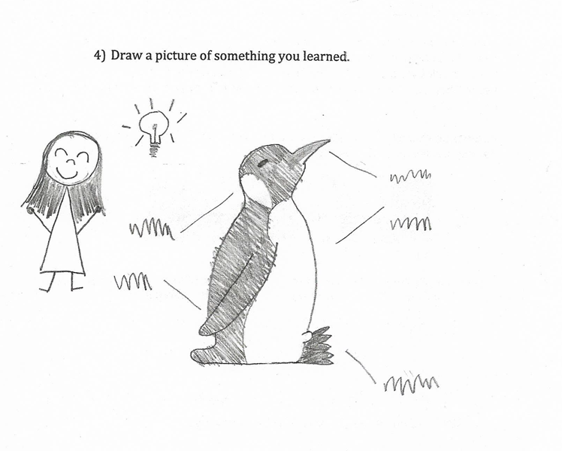
Figure 2
Nayeli’s Exit Ticket
artist has added lines around the bulb to show that it is on and working.

Nayeli communicates both content and process in her drawing. She has leveraged several multimodal tools including placement and layout to transform herself into a successful and bright member of her classroom learning community, regardless of her actual knowledge of the subject matter or the English Learner label she wears to note her student identity.

Vida Gets It

Vida was an intermediate-level language learner and in the fifth grade at the time of the study. Like Nayeli and many others, Vida’s composition depicts her successful acquisition of content knowledge (see Figure 3). However, Vida’s multimodal text is more complex in that it illustrates her gradual process of gaining understanding through Visual Thinking Strategies (Yenawine, 2013). She has drawn a Visual Thinking Strategies (VTS) lesson in which students explored the picture book Tuesday by David Wiesner, the first lesson of the visual based curriculum in every classroom. Vida illustrated a key and climactic scene from the book projected onto a screen, the way it was during class. VTS is essentially a three-question protocol developed to explore artworks and asks: 1) what is going on in this picture? 2) what do you say that makes you say that? 3) what more can we find? (Yenawine, 2013).

Vida showed her own learning in three symmetrical stages moving from confusion (top) to understanding (bottom). This reading path challenges semiotic conventions that place the ideal at the top of the image. However, because the images were sequenced, it makes sense to have illustrated the progression of learning in the way we read linguistic text. This way, she was still depicted as having learned new information. Each balanced layer of the image included a self-portrait with a corresponding speech bubble offset by the lesson content, which remained consistent. Like Nayeli, Vida was placed on the left and the content on the right, reinforcing the known to new horizontal movement in the layout. Vida’s gaze was directed at the content and not the viewer; she was focused on understanding what is on the screen and draws the viewer's attention to that as well. Her movement through the stages of learning are illuminated through gestures (from head scratching to arms raised) and in written text (“what does it mean?” “oh,” “I get it.”). The viewer is directed to follow Vida’s progress through a reading path guided by a series of arrows toward her positive outcome.

Additionally, like Nayeli, Vida used a variety of multimodal techniques to represent herself as a thriving student engaged in learning. The overall layout of her drawing and specifically the placement of herself on the left adds to this perception. Her use of arrows, speech bubbles, and depicted gestures guide the
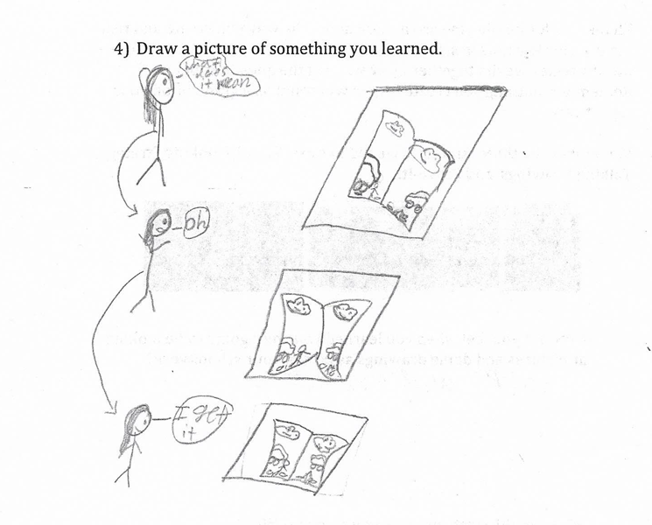
Figure 3
Vida’s Exit Ticket
viewer through the reading path down the left side toward her success. These multimodal elements also demonstrate how Vida is metacognitively aware of her learning processes. Through these multimodal moves in her exit ticket, she created a counternarrative that restoried her classroom status as intermediate-level English learner in her fifth-grade classroom.

Brenda is a Good Student

Like many of the other exit tickets in the data set, Brenda’s multimodal composition captured both the learning content and process (see Figure 4). This fourth grade English Learner centered the lesson’s content information on the page and placed it at the top of the page, helping it become the most salient aspect of the composition. Brenda illustrated the same Visual Thinking Strategy lesson delivered on a screen as Vida; the lesson was repeated as the initial and introductory curriculum engagement in all three participating classrooms. We identified other thematic similarities in Brenda’s drawing. For example, her offer gaze is directed toward the learning and not at the viewer. In addition, we again see the known to new reading path along the horizon moving from left to right.

As in the two other examples, we also find Brenda has illustrated herself into the learning process. She drew herself with all the accoutrements and behaviors of a good student. However, unlike the other exit tickets we highlight here, our author has not drawn herself as successful and thriving. Although she was prepared for the lesson, in her seat, with the required materials, and focused on the image, she had depicted her participation neutrally. Neither her expression, gesture, nor size on the page implied that she was flourishing in the classroom. Brenda included a distinct negative space on the page between herself and the lesson content, and in contrast placed Cappello, who led the lesson, quite nearby. This suggests a distance between our composer and the learning and reinforces the interpretation that she may not have seen herself as successful in this lesson context. Adding to that idea is the written text Brenda added to caption her work. Although she wrote, “The first day was about the frog’s (sic) and it helped me learn a lot,” the lesson was not really about frogs. In the analyzed image from Tuesday, there were references to the frogs that leave their pond and fly around a town. However, we didn’t learn any information about frogs, not their physical or behavioral characteristics. This book is a fantasy and the VTS questioning protocol guided us to find evidence to support our conclusions in the book. Indeed, Brenda’s drawing of the picture book illustration did not include any frogs and instead focused on the mystery. She showed a man being interviewed about what happened in the town. Brenda’s communication in visual and textural modes provide a contrast that is contradictory.
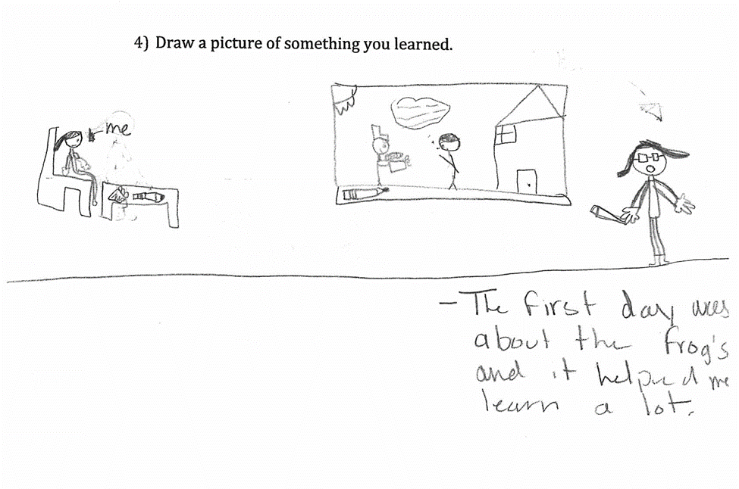
We offer Brenda’s exit ticket as an example to show that not all students used the drawing exercise to create an identity counter narrative. Although she used multimodal resources to communicate learning, her drawing reinforces the power relationships in classrooms and does nothing to transform her position as an English language learner in grade four.
Figure 4
Brenda’s Exit Ticket

Conclusions

Our findings suggest that critical multimodal literacies have the potential to create authorial spaces where the voices of English Learners, who are too often marginalized in our educational systems, can be better understood. These school sanctioned drawings did provide the space and opportunity for our elementary multilingual learners to reflect curriculum content and social identities in their classrooms.

Many of the multilingual learners in this study leveraged visual features, especially those signaling design and interpersonal metafunctions, to assert their identities as successful learners and challenging the deficit classroom narratives often associated with being labeled an English learner by the school, district, and state evaluations. Analyzing multimodal authorial moves such as gaze, placement, and salience viewed through the critical multimodal literacy framework supported our understanding of the multiple ways our multilingual learners communicated through these features and used them to create counter narratives and restory their situations, transforming their socio-political classroom realities. Therefore, we believe the visual-based opportunities in the classroom added to our multilingual learners’ linguistic repertoires. We focused on the critical aspects of how the English Learners’ images served as “language used to convey power and status in contemporary social interaction” (Kress & van Leeuwen, 2006, p. 14). Like Hayik (2011), we understand that since student drawings “reflect the ideas, beliefs and values of its maker, artwork may make the ideological contexts in which it was created visible” (p. 95).

Limitations

There are some notable limitations to this study. First, we had access to a school and classrooms that were interested and invested leveraging visual and multimodal pedagogies to better support their students. We recognize that not all schools are open to innovations. However, we did integrate these methods into the preexisting and mandated curriculum. In addition, although each of the three classrooms provided many additional tools for multimodal authoring, including crayons and markers, we asked students to create exit tickets in pencil. This decision was made to reinforce the idea that drawing is a valued school communication mode and students completed their drawings with the same tool they would use for any other classroom exit ticket. However, now we wonder what color would have added to these reflections and our analysis of them.
“We need to rethink the kinds of authorial tools we offer students and vary the ways in which they can respond to and demonstrate their learning.”

Some might say the lack of corresponding interview data is a limitation. However, this study was designed to elevate visual and multimodal classroom communication and as such the images are the centerpiece of our exploration. We also chose not to interview our students because most elementary students do not have the visual discourses to describe gaze, reading path, and other features; nor do we assume these were intentional visual moves by our multilingual students.

Implications

Findings suggest the multimodal artifacts provided a way for multilingual students to assert themselves into the learning processes and environment as successful participants within their classrooms, implying that teachers should make space for multimodal and visual composing across the curriculum. Including multimodal pedagogies adds to multilingual students’ linguistic repertoires and equity pedagogies that include providing a wide range of tools and multiple pathways for expressing understanding. Teachers might also consider explicitly teaching visual grammar. Although like Early et al. (2015), we caution that visual-based pedagogies are more than an add-on to the long list of skills we demand of our multilingual learners.

We need to rethink the kinds of authorial tools we offer students and vary the ways in which they can respond to and demonstrate their learning. We encourage researchers to take up this call for future studies that explore the impact of multimodal composing in a variety of contexts, including with younger children and with multilingual learners whose first language is something other than Spanish. “The community defines legitimate participation and regulates competency, producing inclusions and exclusions that impact what young people think and how they express themselves” (Chappell & Faltis, 2013, p. 185). As our world becomes increasingly diverse, we need expansive language and literacy practices to support students' reflection on and beyond the curriculum.

References
Ajayi, L. (2015). Critical multimodal literacy: How Nigerian female students critique texts and reconstruct unequal social structures. Journal of Literacy Research, 47(2), 216-244.

Brooks, M. (2009) Drawing, visualisation and young children’s exploration of “Big Ideas”. International Journal of Science Education, 31(3), 319-341. https://doi.org/10.1080/09500690802595771

Brown, D.W., & Albers, O. (2014). Visualizing gender with fifth grade students. Middle Grades Research Journal, 9(1), 85-102.

Cappello, M., & Walker, N. (2021). Talking drawings: A multimodal pathway for demonstrating learning. The Reading Teacher 74(4), 407-418. https://doi.org/10.1002/trtr.1952

Cappello, M., & Walker, N. (2019). Get the picture! Visual Based Literacy Strategies across the curriculum. Teacher Created Materials.

Cappello, M., Wiseman, A.M., & Turner, J.D. (2019). Framing equitable classroom practices: Potentials of critical multimodal literacy research. Literacy Research: Theory Methods and Practice, 68. https://doi.org/10.1177/2381336919870274

Cappello, M., & Walker, N. (2016). Visual Thinking Strategies: Teachers’ reflections on closely reading complex visual texts within the disciplines. The Reading Teacher, 70(3), 317-325. https://doi.org/10.1002/trtr.1523

Cappello, M., & Lafferty, K.E. (2015). The roles of photography for developing literacy across the disciplines. The Reading Teacher, 69(3), 287-295. https://doi.org/10.1002/trtr.1418

California Department of Education (2019). English language learners in California schools. Retrieved from https://www.cde.ca.gov/ds/sg/englishlearner.asp.

Callow, J. (2013). The shape of text to come. Primary English Teaching Association.

Chappell, S.V., & Faltis, C.J. (2013) The arts and emergent bilingual youth: Building culturally responsive, crucial and creative education in school and community contexts. Routledge.

Danzak, R. (2011). Defining identities through multiliteracies: EL teens narrate their immigrations experiences as graphic stories. Journal of Adolescent & Adult Literacy, 55(3). 187-196.

D’warte, J. (2019). Mapping languages and literacies with multilingual students in Australian classrooms. Reading Teacher, 72(5), 663–669. https://doi-org.libproxy.sdsu.edu/10.1002/trtr.1785

Early, M., Kendrick, M., & Potts, D. (2015). Multimodality: Out from the margins of English language teaching. TESOL Quarterly, 49(3), 447-460. Retrieved April 2, 2020, from www.jstor.org/stable/43893767

Education Commission of the States (2014). How is an English language learner defined in state policy? Retrieved from https://ecs.secure.force.com/mbdata/mbquestNB2?rep=ELL1402.

Eisner, E. W. (2002). What can education learn from the arts about the practice of education? Journal of Curriculum and Supervision, 18(1), 4-16.

Ghiso, M.P., & Low, D.E. (2013). Students using multimodal literacies to surface micronarratives of United States immigration. Literacy, 47 (1). 26-34.

Harman, R., & Shin, D. (2018). Multimodal and community-based literacies: Agentive bilingual learners in elementary school. In G. Onchwari & J. Keengwe (Eds.), Handbook of research on pedagogies and cultural considerations for young English language learners. (pp. 217-238). IGI Global.

Hayik, R. (2011). Critical Visual Analysis of multicultural sketches. English Teaching: Practice and Critique, 10(1), 95-118.

Holloway, S.M. (2012) Visual literacies and multiliteracies: An ecology arts-based pedagogical model. Language and Literacy, 14(3), 150-168.

Hull, G., & Katz, M-L. (2006). Crafting the agentive self: Case studies of digital storytelling. Research in the Teaching of English, 41(1). 43-81.

Janks, H. (2013). Critical literacy in teaching and research. Education Inquiry, 4, 225–242.

Kedra, J., & Zakeviciute, R. (2019) Visual literacy practices in higher education: What, why and how? Journal of Visual Literacy, 38(1-2). 1-7.

Kendrick, M., & McKay, R. (2005). Drawings as an alternative way of understanding young children's constructions of literacy. Journal of Early Childhood Literacy, 4(1), 109-128.

Kress, G., & van Leeuwen, T. (2006). Reading images: The grammar of visual design, 2nd ed. Routledge.

Kuby, C. (2012). Evoking emotions and unpacking layered histories through young children's illustrations of racial bus segregation. Journal of Early Childhood Literacy, 13(2), 271-300.

Marquez-Zenkov, K., & Harmon, J.A. (2007). Seeing English in the city: Using photography to understand students’ literacy relationships. English Journal, 96(6), 24-30.

Marzano, R.J., Pickering, D.J., & Pollock, J. (2001). Classroom instruction that works: Research-based strategies for increasing student achievement. Association for Supervision and Curriculum Development.

McConnell, S. (1992). Talking drawings: A strategy for assisting learners. Journal of Reading, 36(4), 260-269.

Muhammad, G. E., & Womack, E. (2015). From pen to pin: The multimodality of Black girls (re) writing their lives. Ubiquity: The Journal of Literature, Literacy, and the Arts, 2, 6-45.

Ranker, J. (2014). The role of semiotic resource complexes in emergent multimodal reading process: Insights from young student’s reading of a comic book. Australian Journal of Language and Literacy, 37(3), 151-160.

Serafini, F., & Reid, S. F. (2019). Multimodal content analysis: expanding analytical approaches to content analysis. Visual Communication. https://doi.org/10.1177/1470357219864133

Short, K., Kauffman, G., & Kahn, L. (2000). "I just need to draw": Responding to literature across multiple sign systems. The Reading Teacher, 54(2), 160-171.

Vorobel, O., Kim, D., & Park, H.-R. (2020). An Adolescent English Learner’s Expression of Self and Identity through Multiliteracy Practices. Journal of Educational Research, 113(5), 327–334.

Whitelaw, J., & Wolf, S. (2001). Learning to "see beyond": Sixth-grade students' artistic perceptions of "The Giver.". New Advocate, 14(1), 57.

Whitin, P. (2005). The interplay of text, talk, and visual representation in expanding literary interpretation. Research in the Teaching of English, 39(4), 365-397.

Wolfe, P. (2010). Transmediation as a tool for English language learners to access academic discourse. National Society for the Study of Education, 109(2). 438-452.

Yenawine, P. (2013). Visual thinking strategies. Harvard Education Press.

Zapata, A., & Van Horn, S. (2017). “Because I’m smooth”: Material intra-actions and text productions among young Latino picture book makers. Research in the Teaching of English, 51(3), 290-316.

Zoss, M., Siegesmund, R., & Patisaul, S.J. (2010). Seeing, writing, and drawing the intangible: teaching with multiple literacies. In P. Albers & J. Sanders (Eds.). Literacies, the Arts, and Multimodality. NCTE

Children’s Literature Cited

Wiesner, D. (2011). Tuesday. Clarion Books.

